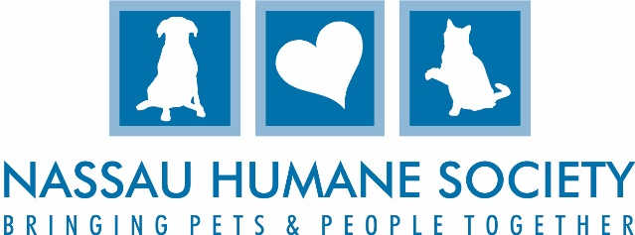

Nassau Humane Society Volunteer Application
Young adults between the ages of 12 and 15 must be accompanied by their legal guardian at all times. Applications and Waivers must be signed by legal guardian for young adults between the ages of 12 and 17. Children under the age of 12 are not allowed to volunteer. All Volunteers MUST be approved by
Nassau Humane Society before volunteering.

Please indicate age _____. Date of Birth: ____________

Name___________________________________________________Date_________________________
Address_____________________________________City________________State______Zip__________
Home#_____________________________________Cell#______________________________________
E-Mail_____________________________________ Company or School__________________________

We appreciate your desire to make a difference in the lives of animals waiting for their permanent homes. Please review the different volunteer opportunities and check all that interest you.
I would prefer to work with: Dogs ____ Cats_____ Both_____ Neither_____
I prefer to work:
Weekdays _____ Weekends_____ Mornings _____ Afternoons _____ Doesn’t Matter
Housekeeping /Shelter _____ | Foster Care _____
Dog Park Assistant _____ | Pet Training/Therapy _____
Dog Park Pool Attendant ______ | Remote Adoptions _____
Second Chance Resale Shop _____ | Fundraising /Special Events _____
Cleaning the Cattery _____ | Event Committees _____
Cat Socialization _____ | Marketing/PR _____
Dog Walking _____ | Landscaping _____
Cleaning Dog Kennels _____ | General Maintenance_____
Miscellaneous duties at shelter _____ | Animal Enrichment (Filling Kongs ect. )_____

Please describe any special skills and interests that you would like to share with us:
_______________________________________________________________________________________________________________________________________________________________________________________________________________________________________________________________
_____________________________________________________________________________________
_____________________________________________________________________________________
By signing below, I acknowledge that Nassau Humane Society (“NHS”) has warned me that working in an animal shelter with cats and dogs can expose me to animal bites/scratches and other injuries because all animals are unpredictable. I further acknowledge that I believe NHS has taken all reasonable precautions to protect me from injury, and that I expressly assume any risk. Finally, I acknowledge that I am undertaking my volunteer work willingly and of my own accord, and that I hold NHS harmless for any injuries that I suffer as a volunteer.
Nassau Humane Society will take all reasonable precautions to protect volunteer demographics and personal data and information will not be given to a third party.
You must agree to the above terms to submit an application. A completed and signed waiver must accompany this application.
As a parent or legal guardian, I agree to the above terms for my young adult under 18 years of age and I submit his/her application.
Signature _________________________________________________Date__________________
Parent/Guardian Signature __________________________________ Date _________________
(Required under the age of 18 years old.)

Staff Signature_____________________________________________

Return to: Volunteer Manager
Nassau Humane Society
639 Airport Road
Fernandina Beach, FL 32034
904-321-1647
volunteer@nassauhumane.org
www.nassauhumane.org

Thank you for caring to help our homeless animals. Please visit our website for more information about the Nassau Humane Society at www.nassauhumane.org

